

|  |  |
| --- | --- |
|  | Asia Gateway Corporate Services  Your Online Receptionist  User Guide |
|  |  |

Contents

1. Setting up your call centre management system 3

Log in 3

2. Understanding Your Dashboard 4

Getting Started

Welcome and thank you for choosing online receptionist as your call centre management facility.

By now you would have received your Username & Password, kindly proceed to [www.online-receptionist.com/client](http://www.online-receptionist.com/client) to setup your call centre management facility.

# Setting up your call centre management system

## Log in

1. Enter your **Username** and **Password** provided to you into the Login
2. Enter the dynamic **Security Code** as shown in the figure below.

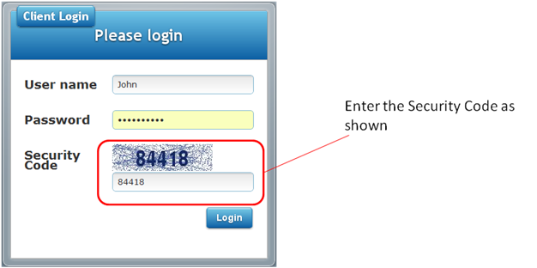

1. Click on the **Login** button.
2. If you have entered a wrong password or username, the system will prompt you to re-enter your correct username and password. Please note that your username and password is **case-sensitive**.

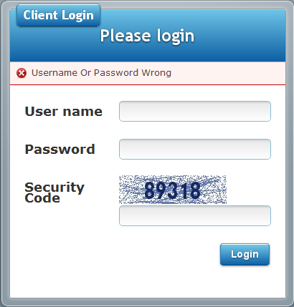

1. Understanding Your Dashboard

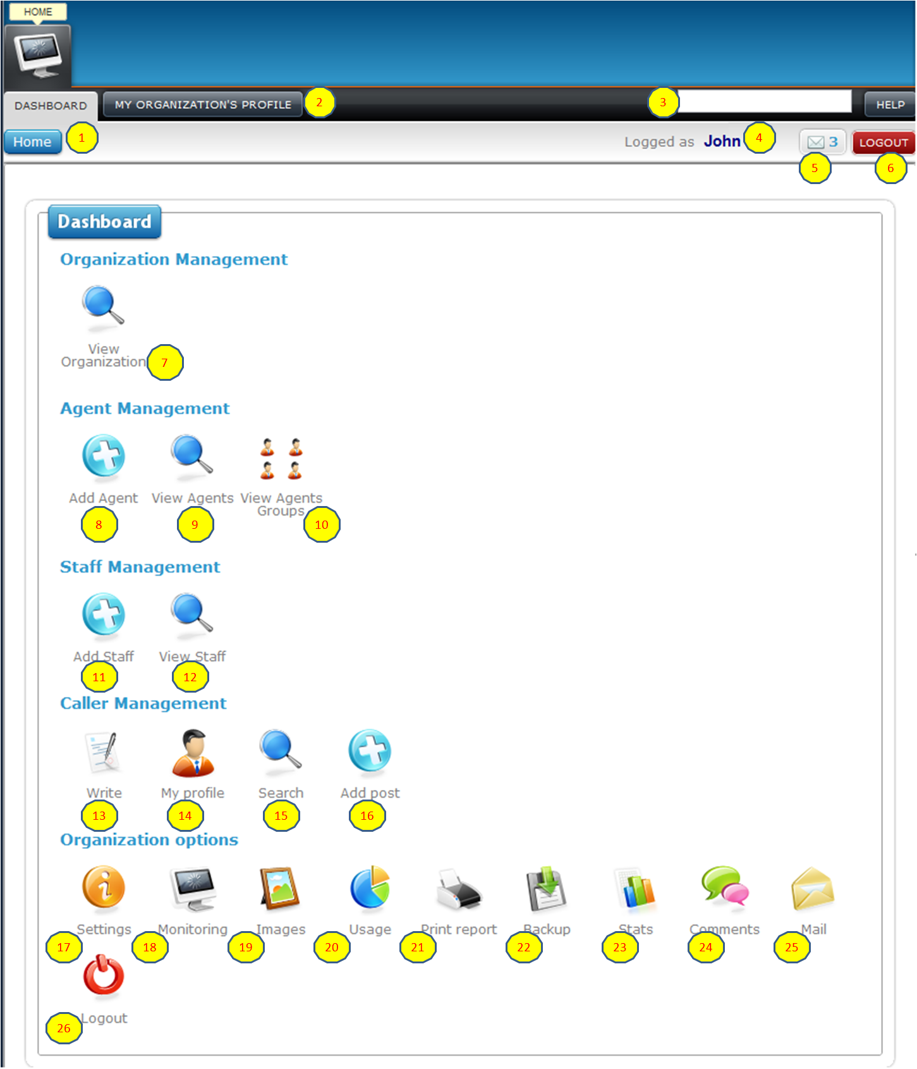

Figure 2a - Dashboard

### Dashboard Navigation

1 – Home Button: this button will bring you the user back to the dashboard to select other settings.

2 – My Organization Profile: this tab will allow the user to edit the name of your organization.

3 – Search data field & Help Button: type in your question and click on the help button to get answers to your queries.

4 – User Logged In: this shows the name of the user logged into the system

5 – Mail Button: this shows the number of mail this user has, clicking on this button will launch the web-based mail page.

6 – Logout button: Use this button to logout of the system.

7 – View Organization button: this button will allow user to review & edit the company name, and allow for editing and creation of the following:

7.1 Agent Groups

7.2 Agent

7.3 Sites

7.4 Staff

7.5 Exporting of above information to an excel file

8 -